Project Design Phase
Solution Architecture
Date | 20 February 2026
Team ID | LTVIP2026TMIDS70689
Project Name | HouseHunt: Finding Your Perfect Rental Home
Maximum Marks | 4 Marks

Solution Architecture:
Solution architecture bridges business problems and technology solutions. The HouseHunt system provides a centralized web platform for searching and listing rental properties. It connects users, property owners, and administrators through a secure and scalable architecture.

Architecture Diagram:
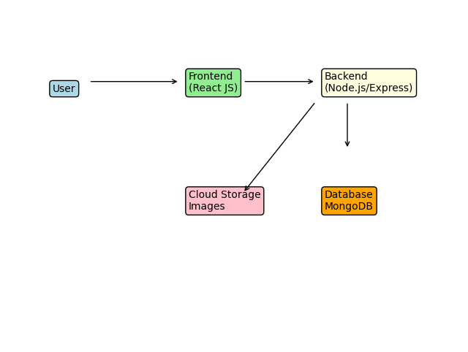

Architecture Description:
1. Users access the application using a web browser.
2. Frontend developed using HTML, CSS, JavaScript and React JS provides interactive UI.
3. Backend developed using Node.js and Express handles requests and application logic.
4. MongoDB database stores user, property and admin data securely.
5. Cloud/local storage stores property images.
6. Admin monitors and manages users and property listings.
7. The architecture is scalable and can be deployed on cloud platforms.

